ENGL 3110 - Exam One - Spring 2026 — ANSWER KEY
Total Points: 100 • Time: 70 Minutes
Resources: Anything except help from other people or AI/LLM (ChatGPT, etc.)
Sections:
- Section A: Multiple Choice — 50 points (25 questions, 2 points each) — Suggested Time: 30 minutes
- Section B: Sentence Labeling and Diagramming — 50 points (5 sentences, 10 points each) — Suggested Time: 30 minutes
- Bonus — 10 points (5 questions, 2 points each)

Section A: Multiple Choice (50 points)

Section A1: Morphology and Word Structure (Questions 1–8, 16 points)
Question 1: How many morphemes does the word "disagreements" contain? (2 pts)
Answer: d
a. 1
b. 2
c. 3
d. 4 — dis- (bound) + agree (free) + -ment (bound) + -s (bound)
Question 2: Which of the following words contains exactly one morpheme? (2 pts)
Answer: b
a. unfriendly — 3 morphemes: un- + friend + -ly
b. describe — 1 morpheme. Although it appears to begin with de-, the remaining -scribe does not combine with de- to produce the word’s meaning compositionally.
c. replayable — 3 morphemes: re- + play + -able
d. misplace — 2 morphemes: mis- + place
Question 3: Which test reliably distinguishes adjectives from determiners? (2 pts)
Answer: b
a. Adjectives can be pluralized — Incorrect. Nouns are pluralized, not adjectives.
b. Adjectives can be “gradeable” — they have comparative and superlative forms (e.g., taller/tallest or more challenging/most challenging) — Correct. Determiners do not have comparative or superlative forms: you cannot say "taller the" or "more the."
c. Adjectives always appear after the noun — Incorrect. Adjectives typically appear before the noun in attributive position.
d. Adjectives cannot appear before nouns — Incorrect. Adjectives routinely appear before nouns (the tall man).
Question 4: The suffix -tion typically creates which word class? (2 pts)
Answer: c
a. Verb
b. Adjective
c. Noun — -tion converts verbs into nouns: action, creation, decision
d. Adverb
Question 5: Which word is an example of a compound (formed from two free morphemes)? (2 pts)
Answer: c
a. understand — 1 morpheme. The meaning does not derive from "under" + "stand."
b. carpet — 1 morpheme. "Car" + "pet" is coincidental resemblance.
c. bookcase — 2 free morphemes: book + case. The meaning is compositional.
d. receive — 1 morpheme. "Ceive" is not a word in modern English.
Question 6: The word "unhelpful" contains how many morphemes? (2 pts)
Answer: c
a. 1
b. 2
c. 3 — un- (bound) + help (free) + -ful (bound)
d. 4
Question 7: Which of the following correctly identifies the morphemes in "rebuilding"? (2 pts)
Answer: a
a. re- (bound) + build (free) + -ing (bound) — Correct. re- is a bound prefix meaning "again," build is the free base, -ing is bound.
b. re- (free) + build (free) + -ing (bound) — Incorrect. re- is bound, not free.
c. rebuild (free) + -ing (bound) — Incorrect. rebuild can be further divided.
d. re- (bound) + building (free) — Incorrect. building should be divided into build + -ing.
Question 8: According to the basic structure of English sentences, every sentence (S) divides into which two parts? (2 pts)
Answer: c
a. Determiner + Sentence
b. Noun + Verb — Too narrow; subjects and predicates are phrases, not just single words.
c. Subject NP + Predicate VP — Correct. S → NP + VP is the fundamental structure of every English sentence.
d. Adjective Phrase + Verb Phrase

Section A2: Open and Closed Classes (Questions 9–16, 16 points)
Question 9: Which of the following word classes is an open class? (2 pts)
Answer: c
a. Determiners — closed class
b. Pronouns — closed class
c. Adjectives — open class (readily accepts new members: viral, binge-worthy, gluten-free)
d. Prepositions — closed class
Question 10: Which feature best distinguishes determiners from adjectives? (2 pts)
Answer: c
a. Determiners appear after the noun — Incorrect. Determiners appear before the noun.
b. Determiners can be modified by "very" — Incorrect. Adjectives can be modified by "very"; determiners cannot.
c. Determiners must appear before any adjectives in a noun phrase — Correct. DET + ADJ + N (the tall man, not tall the man).
d. Determiners describe qualities of the noun — Incorrect. Adjectives describe qualities; determiners specify reference.
Question 11: In the phrase "the tall student from Ohio," which word is the head of the noun phrase? (2 pts)
Answer: c
a. the — determiner (modifier)
b. tall — adjective (modifier)
c. student — The head noun. Cannot be removed without destroying the phrase.
d. Ohio — head of a nested NP inside the PP, not the head of the main NP.
Question 12: Which of the following words is a determiner? (2 pts)
Answer: c
a. beautiful — adjective
b. quickly — adverb
c. every — determiner (appears before adjectives; cannot be modified by "very")
d. student — noun
Question 13: "The professor entered the room and placed her notes on the desk." What is the antecedent of "her"? (2 pts)
Answer: b
a. The room
b. The professor — "her" (third person, singular, feminine) refers back to "The professor."
c. The desk
d. her notes
Question 14: Pronouns replace which of the following elements? (2 pts)
Answer: b
a. Only the head noun
b. The entire noun phrase — Correct. Pronouns replace the full NP including all modifiers: "the tall student from Ohio" → "she."
c. Only the determiner and noun
d. The verb phrase
Question 15: Which of the following words is a preposition? (2 pts)
Answer: c
a. quickly — adverb
b. beautiful — adjective
c. through — preposition
d. they — pronoun
Question 16: Which of the following is NOT a determiner? (2 pts)
Answer: c
a. the — determiner
b. every — determiner
c. very — adverb (modifies adjectives and adverbs, not nouns)
d. some — determiner

Section A3: Parts of Speech in Context (Questions 17–25, 18 points)
Sentence for Questions 17–18: "Several enthusiastic students quietly studied the challenging material."
Question 17: Which word in the sentence above is a determiner? (2 pts)
Answer: b
a. enthusiastic — adjective
b. Several — determiner (indicates amount; cannot be modified by "very"; appears before adjectives)
c. quietly — adverb
d. challenging — adjective
Question 18: In the sentence “Several enthusiastic students quietly studied the challenging material,” which word is an adverb? (2 pts)
Answer: c
a. Several — determiner
b. enthusiastic — adjective
c. quietly — adverb (modifies the verb "studied"; formed with -ly from quiet)
d. material — noun
Question 19: "The professor with the briefcase lectured brilliantly." What part of speech is "with"? (2 pts)
Answer: c
a. Conjunction
b. Determiner
c. Preposition — "With" introduces the prepositional phrase "with the briefcase."
d. Adverb
Question 20: "My sister carefully examined their proposal." Which word is functioning as a verb? (2 pts)
Answer: d
a. My — determiner
b. sister — noun
c. carefully — adverb
d. examined — verb (the main action; takes past tense -ed)
Question 21: "Three playful kittens explored the mysterious basement." Which word is an adjective? (2 pts)
Answer: b
a. Three — determiner
b. playful — adjective (describes a quality; can be modified by "very"; formed with -ful)
c. explored — verb
d. basement — noun
Question 22: "She quickly ran to the store." What type of phrase is "to the store"? (2 pts)
Answer: d
a. Noun phrase
b. Verb phrase
c. Adjective phrase
d. Prepositional phrase — Headed by the preposition "to," with "the store" as its NP object.
Question 23: In the phrase "the extremely tall building," what word class does "extremely" belong to? (2 pts)
Answer: b
a. Adjective
b. Adverb — "Extremely" modifies the adjective "tall," telling the degree of tallness.
c. Determiner
d. Noun
Question 24: In the sentence “The professor from the university in Boston retired last spring,” what word does the prepositional phrase “in Boston” modify? (2 pts)
Answer: c
a. professor — Incorrect. "professor" is the head of the outer NP, modified by the entire PP "from the university in Boston."
b. spring — Incorrect. "spring" is a noun in a separate time expression.
c. university — Correct. "in Boston" modifies "university" — the head noun of the NP inside the PP "from the university."
d. retired — Incorrect. "retired" is the verb; the PP "in Boston" modifies a noun, not the verb.
Question 25: In the sentence “The remarkably patient nurse explained the procedure slowly,” what word does the adverb “remarkably” modify? (2 pts)
Answer: d
a. nurse — Incorrect. "nurse" is a noun; adverbs do not modify nouns.
b. explained — Incorrect. "explained" is the verb; "slowly" modifies the verb, not "remarkably."
c. slowly — Incorrect. "slowly" is itself an adverb modifying the verb "explained."
d. patient — Correct. "remarkably" is an adverb modifying the adjective "patient," indicating degree.

Section B: Sentence Labeling and Diagramming (50 points)
Instructions: For each sentence below, take two steps.
1. Complete the labeling table by filling in the Role, Phrase, and Part of Speech (POS) rows.
2. Create a tree diagram of the sentence. You may use any diagramming tool of your choice: SyntaxTreeHybrid, by hand on paper, or by hand on a tablet.
Scoring (per sentence):
- 4 points — Correct Parts of Speech
- 3 points — Correct Phrase labels
- 1 point — Correct Role labels (Subject, Predicate)
- 2 points — Correct tree diagram
Abbreviation Key
Parts of Speech | Phrase Types | Roles
Noun = N | Noun Phrase = NP | Subject = Subj
Verb = V | Verb Phrase = VP | Predicate = Pred
Adjective = ADJ | Adjective Phrase = ADJP
Adverb = ADV | Adverb Phrase = ADVP
Determiner = DET | Prepositional Phrase = PP
Preposition = PREP | Sentence = S
Notes:
- In the Phrase row, label the main verb as VP (Verb Phrase). The VP label in the table applies to just the main verb itself.
- In the Role row, label the subject noun phrase as Subject and the verb phrase as Predicate. Leave other role cells empty.
- Always include a phrase level for nouns, verbs, adjectives, adverbs, and prepositions.
Example: The old man sat quietly.
Role | Subject |  |  | Predicate
Phrase | NP |  |  | VP | ADVP
Word | The | old | man | sat | quietly
POS | DET | ADJ | N | V | ADV
Bracket notation: [S [NP [DET The] [ADJP [ADJ old]] [N man]] [VP [V sat] [ADVP [ADV quietly]]]]
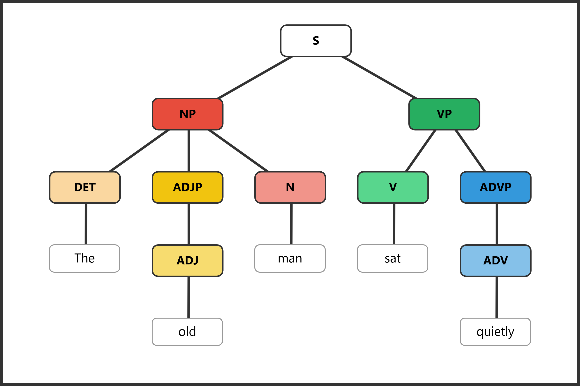

Question 26: (10 pts) The cat slept on her comfy bed.
Role | Subject |  | Predicate
Phrase | NP |  | VP | PP
Word | The | cat | slept | on | her | comfy | bed
POS | DET | N | V | PREP | DET | ADJ | N
Bracket notation (instructor reference): [S [NP [DET The] [N cat]] [VP [V slept] [PP [PREP on] [NP [DET her] [ADJP [ADJ comfy]] [N bed]]]]]
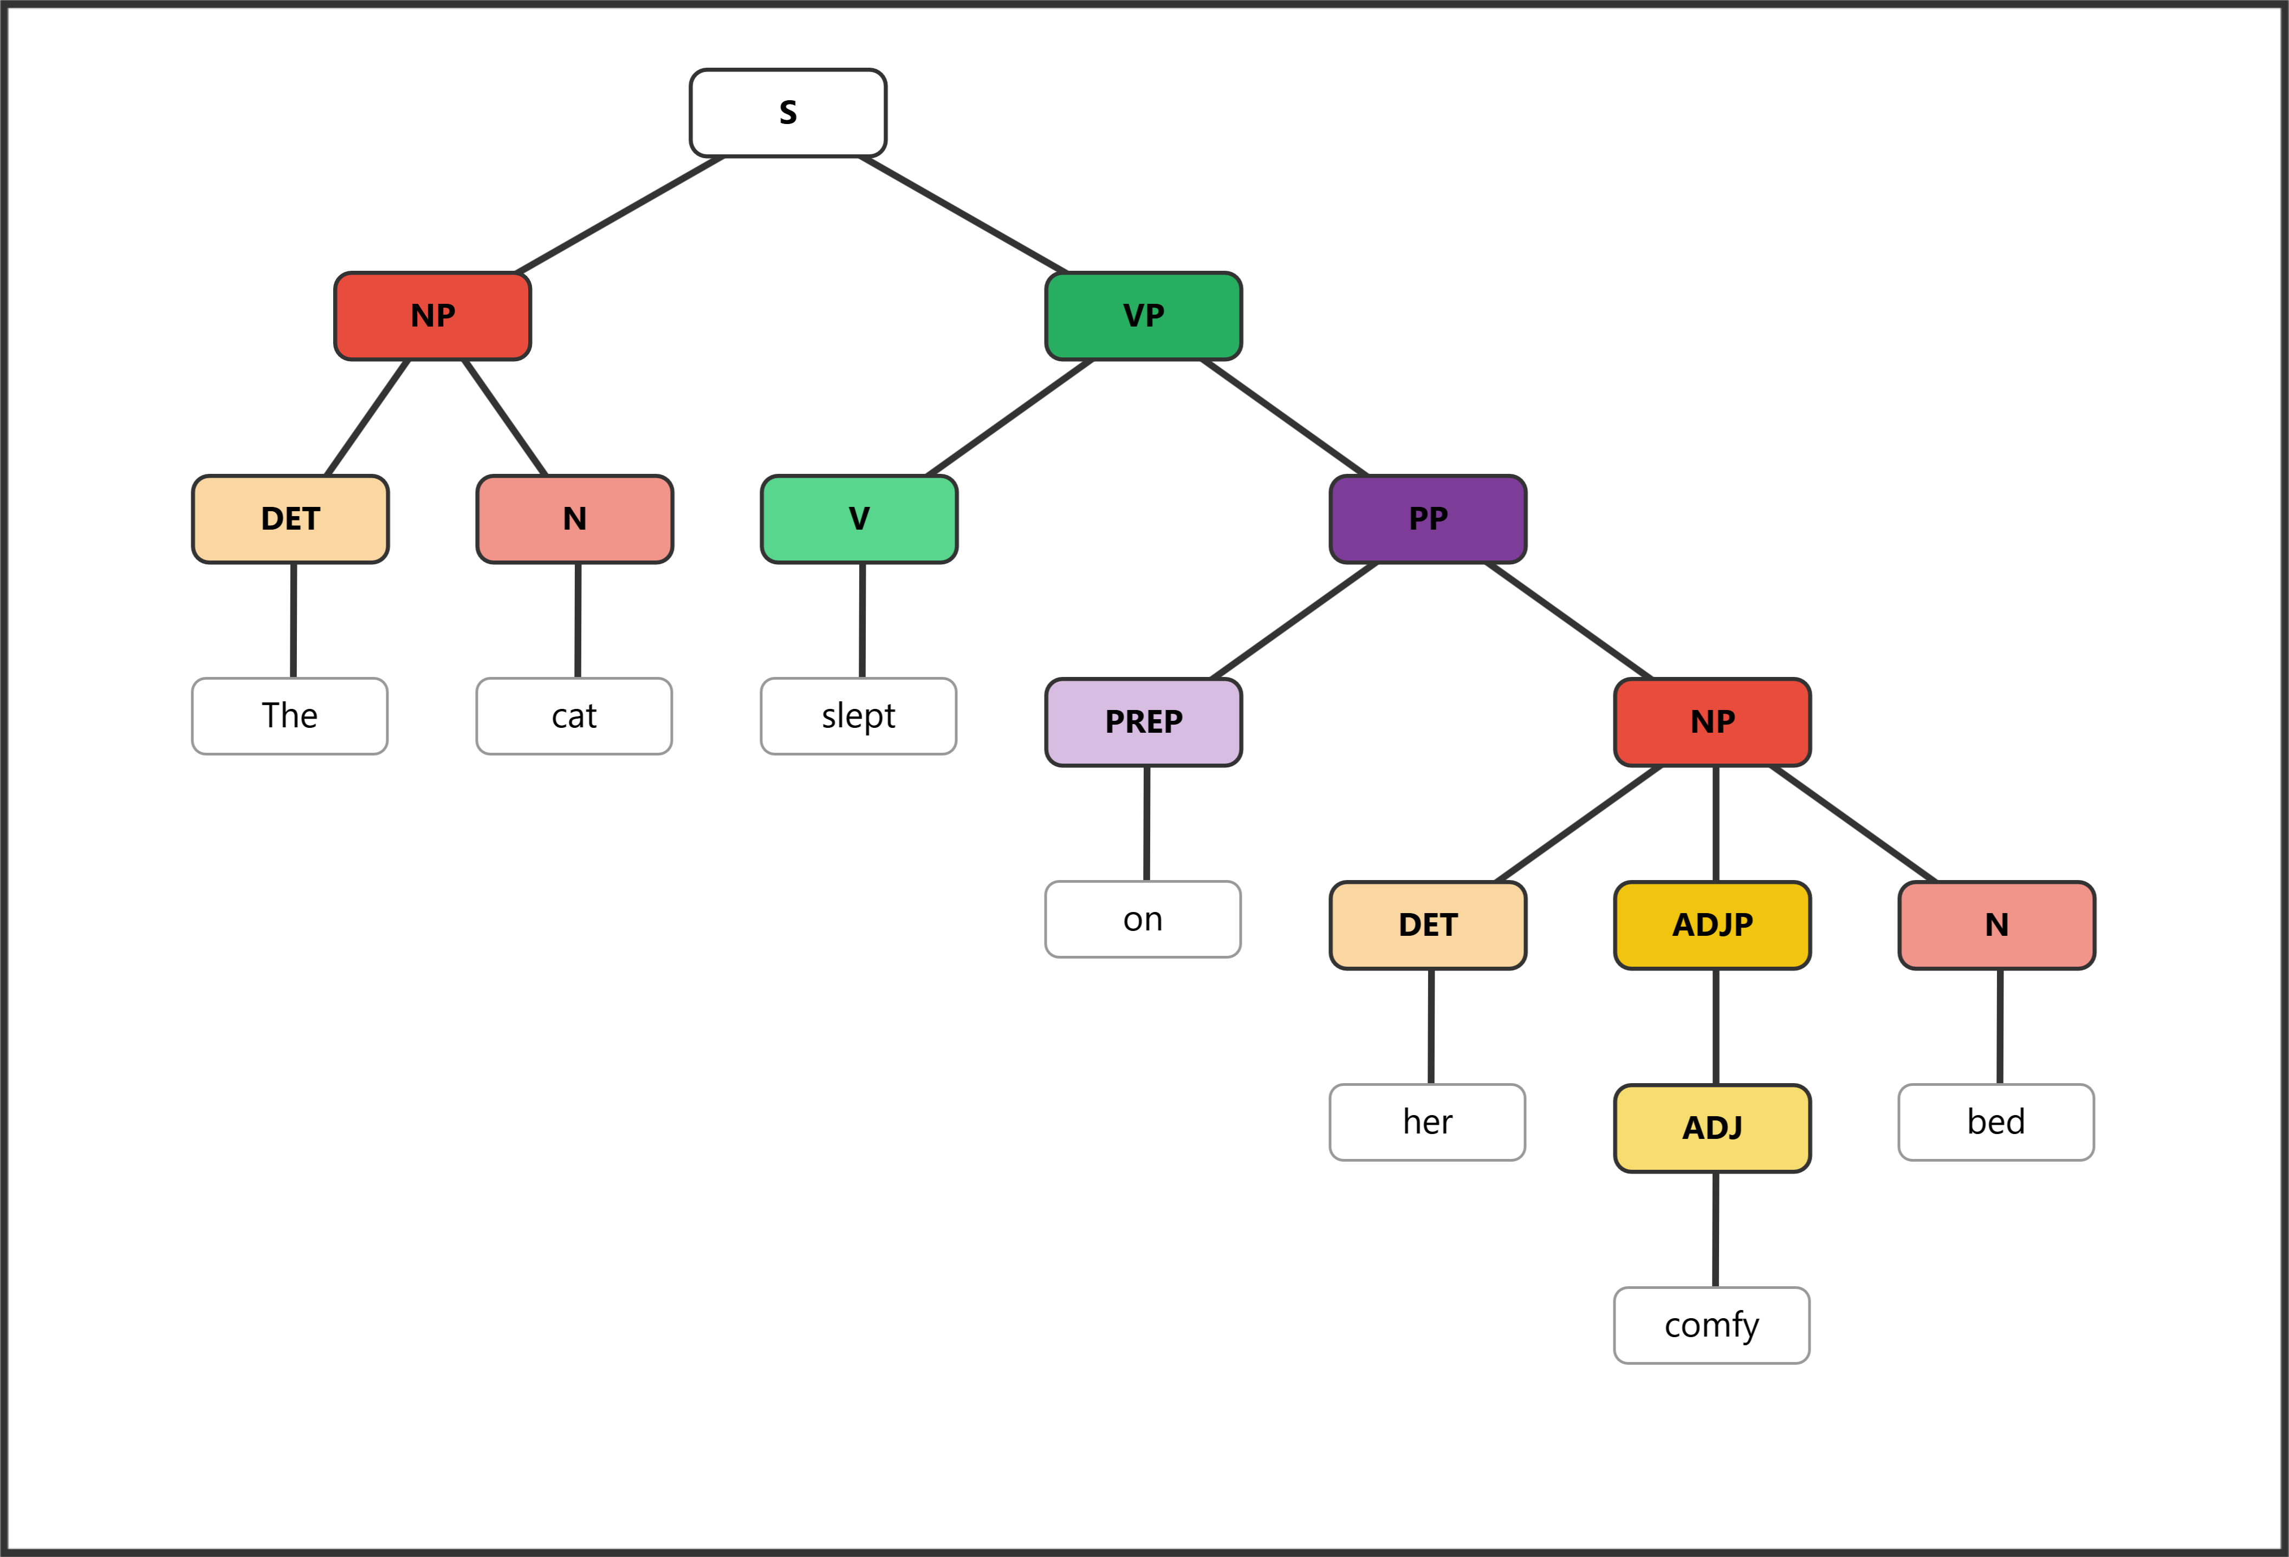

Question 27: (10 pts) The cheerful birds sang beautifully in the garden.
Role | Subject |  |  | Predicate
Phrase | NP |  |  | VP | ADVP | PP
Word | The | cheerful | birds | sang | beautifully | in | the | garden
POS | DET | ADJ | N | V | ADV | PREP | DET | N
Bracket notation (instructor reference): [S [NP [DET The] [ADJP [ADJ cheerful]] [N birds]] [VP [V sang] [ADVP [ADV beautifully]] [PP [PREP in] [NP [DET the] [N garden]]]]]
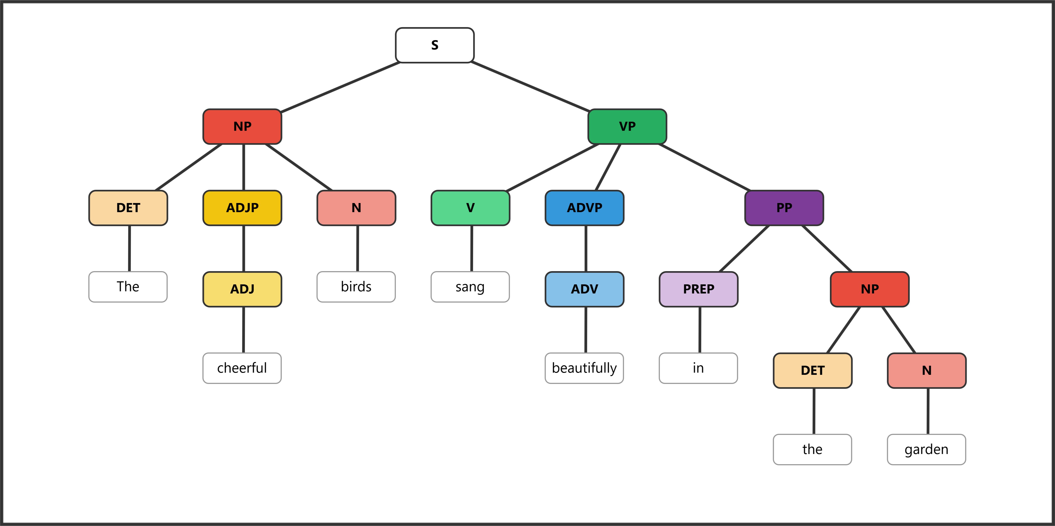

Question 28: (10 pts) The students from Ohio studied carefully.
Role | Subject |  |  |  | Predicate
Phrase | NP |  | PP |  | VP | ADVP
Word | The | students | from | Ohio | studied | carefully
POS | DET | N | PREP | N | V | ADV
Bracket notation (instructor reference): [S [NP [DET The] [N students] [PP [PREP from] [NP [N Ohio]]]] [VP [V studied] [ADVP [ADV carefully]]]]
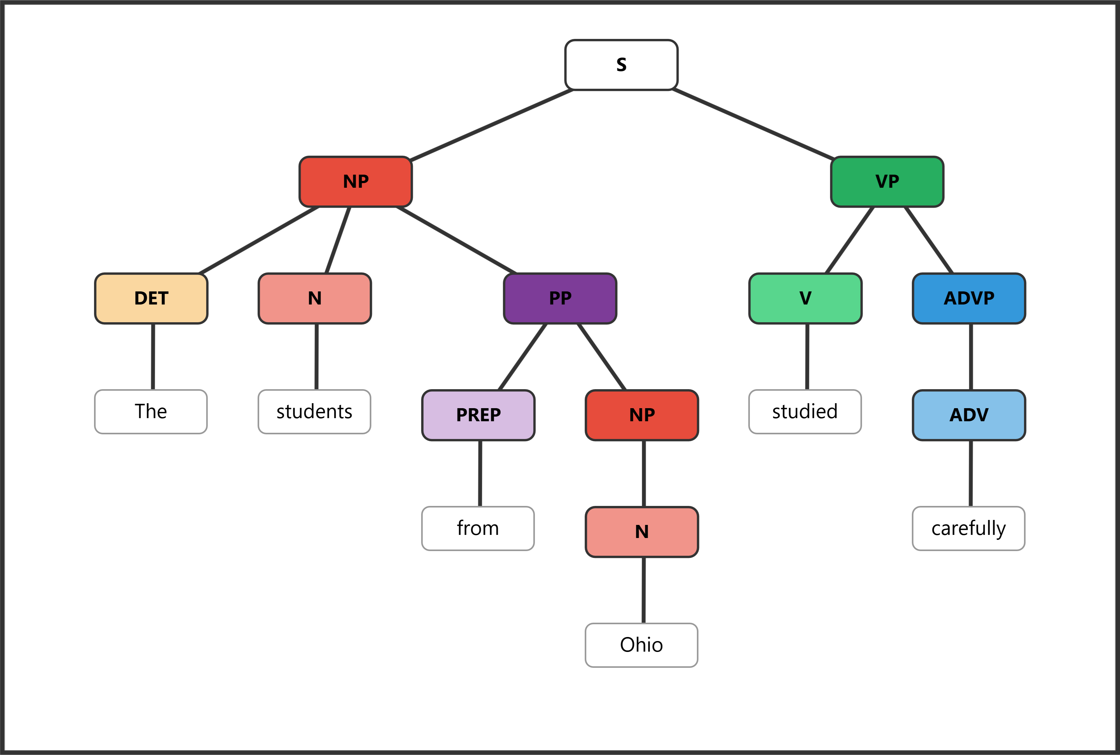

Question 29: (10 pts) Several brave firefighters worked tirelessly during the dangerous storm.
Role | Subject |  |  | Predicate
Phrase | NP |  |  | VP | ADVP | PP
Word | Several | brave | firefighters | worked | tirelessly | during | the | dangerous | storm
POS | DET | ADJ | N | V | ADV | PREP | DET | ADJ | N
Bracket notation (instructor reference): [S [NP [DET Several] [ADJP [ADJ brave]] [N firefighters]] [VP [V worked] [ADVP [ADV tirelessly]] [PP [PREP during] [NP [DET the] [ADJP [ADJ dangerous]] [N storm]]]]]
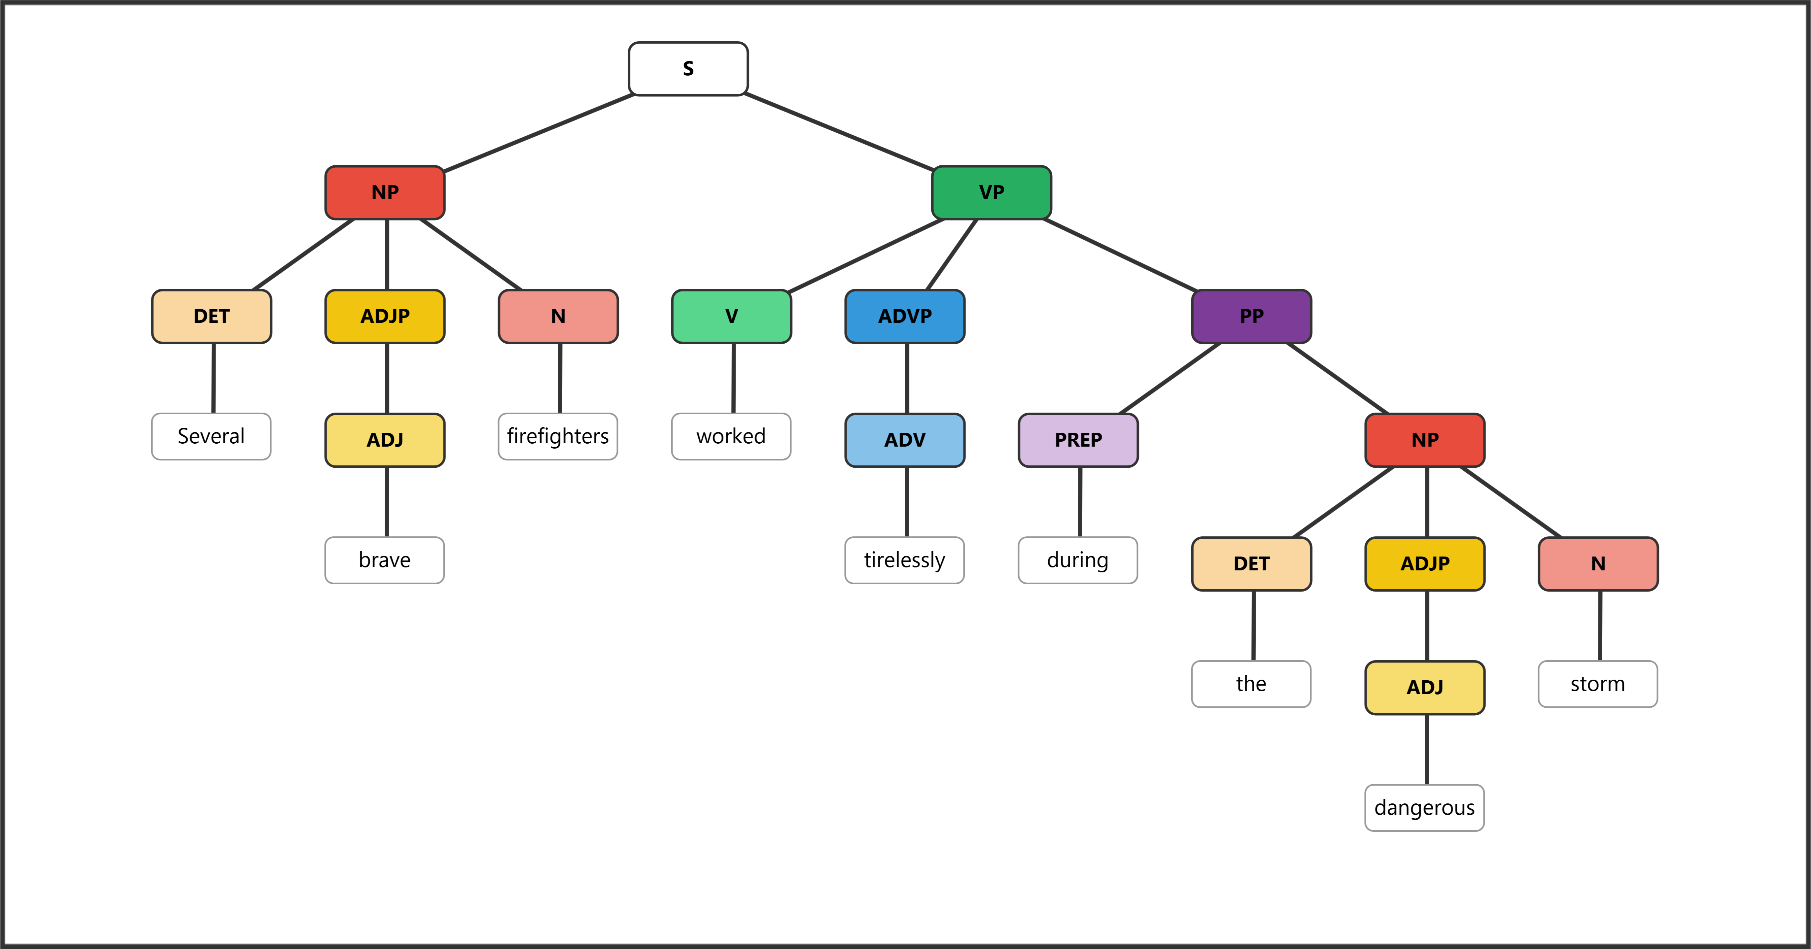

Question 30: (10 pts) The tall professor with gray hair spoke very eloquently.
Role | Subject |  |  |  |  |  | Predicate
Phrase | NP |  |  | PP |  |  | VP | ADVP
Word | The | tall | professor | with | gray | hair | spoke | very | eloquently
POS | DET | ADJ | N | PREP | ADJ | N | V | ADV | ADV
Bracket notation (instructor reference): [S [NP [DET The] [ADJP [ADJ tall]] [N professor] [PP [PREP with] [NP [ADJP [ADJ gray]] [N hair]]]] [VP [V spoke] [ADVP [ADVP [ADV very]] [ADV eloquently]]]]
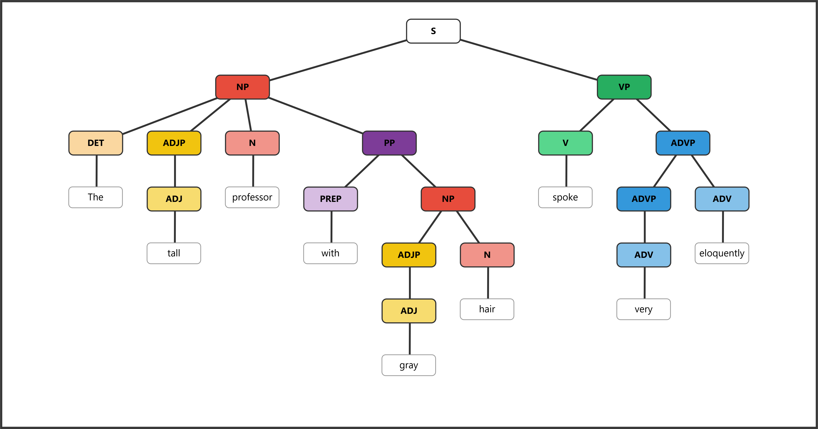

Bonus (10 points)
Answers will vary. Accept any response that correctly demonstrates the required feature.
Bonus 1: Write a sentence containing a compound word (a word formed from two free morphemes). Underline or circle the compound word and identify its two free morphemes. (2 pts)
Example: I placed the flowers on the bookshelf. Free morphemes: book + shelf
Award 1 pt for a valid sentence with the compound word identified, and 1 pt for correctly naming both free morphemes.
Bonus 2: Write a sentence containing a prepositional phrase that modifies the verb phrase (not a noun). Underline or circle the prepositional phrase. (2 pts)
Example: She ran in the park. (The PP “in the park” modifies the verb “ran,” telling us where the action happened.)
Award 1 pt for a valid sentence and 1 pt for correctly identifying a PP that modifies the VP (not a noun).
Bonus 3: Write a word that contains at least three morphemes. List each morpheme and label it as free or bound. (2 pts)
Example: "unhappiness" — un- (bound) + happy (free) + -ness (bound) = 3 morphemes
Award 1 pt for a valid word with 3+ morphemes and 1 pt for correct labeling of each morpheme.
Bonus 4: Write a noun phrase that contains a determiner, an adjective, and a noun. (2 pts)
Example: "the brave soldier"
Award 1 pt for including all three elements and 1 pt for correct word class identification (DET + ADJ + N).
Bonus 5: Write a sentence in which an adverb modifies an adjective (not a verb). Underline or circle the adverb and identify the adjective it modifies. (2 pts)
Example: "The incredibly fast runner won the race." (incredibly modifies the adjective fast)
Award 1 pt for a sentence where an adverb modifies an adjective and 1 pt for correctly identifying both the adverb and the adjective.

Quick Answer Reference
Question | Answer | Question | Answer
1 | d | 14 | b
2 | b | 15 | c
3 | b | 16 | c
4 | c | 17 | b
5 | c | 18 | c
6 | c | 19 | c
7 | a | 20 | d
8 | c | 21 | b
9 | c | 22 | d
10 | c | 23 | b
11 | c | 24 | c
12 | c | 25 | d
13 | b

